DENTON COMMUNITY MARKET
CERTIFIED FARMERS
SNAP/WIC HANDBOOK

- Introduction
The Denton Community Market administers and maintains SNAP (Supplemental Nutrition Assistance Program) and WIC FMNP (Women, Infant, and Children - Farmers Market Nutrition Program) in order to promote healthy food options that support local farmers, and improve the health of our community. The program purpose is to increase consumption of fresh fruits and vegetables and provide opportunities for farmers to sell their produce locally.

Customers who have WIC benefits through WIC FMNP Vouchers, or SNAP benefits through their Lone Star Card (EBT) may now make qualified purchases at the Denton Community Market. The Market received a USDA grant in partnership with the City of Denton to enable lower income individuals to purchase fresh produce and other agricultural products.

SNAP & WIC FMNP recipients are not treated any differently than any other customer - they simply use a different purchasing option. The goal is to help low-income households have healthy diets.
https://www.fns.usda.gov/ebt/snap-and-farmers-markets
http://farmersmarketcoalition.org/advocacy/
http://farmersmarketcoalition.org/advocacy/snap/
http://farmersmarketcoalition.org/advocacy/wic-farmers-market-nutriton-program/
https://farmersmarketcoalition.org/education/snap/
http://www.squaremeals.org/Programs/FarmersMarketNutritionProgram.aspx

SNAP + WIC | WIC | SNAP
- DCM approved Vendors: producer only & local.  - Clients pick up tokens/vouchers from DCM Booth  - Vendors turn in tokens/vouchers to DCM Staff after each Market day. | - DCM Agricultural producers that sell allowed* fresh fruits and vegetables  - Clients give vouchers in $6 increments  - Vouchers are redeemed monthly  - DCM Program Dates: April - October | - DCM Agricultural producers, Cottage Food vendors, and Food vendors that meet Criterion B*  - Clients give tokens in $1 increments  - Tokens can be redeemed weekly  - DCM Program Dates: April - November

- WIC

VENDORS ELIGIBLE TO ACCEPT WIC: DCM agricultural producers already meet the criteria as an authorized farmer because we are a local (within 100 miles) and producer-only market. FMNP vouchers may only be redeemed for producer grown products of unprepared fruits, vegetables, and herbs for human consumption.
DCM is working with GROW North Texas to administer WIC FMNP:
- GROW North Texas is the Contracting Entity: manages agreements, training, and distribution and reconciliation of vouchers, record keeping, and payments with Texas Dept. of Agriculture.
- DCM is the Farmers’ Market Association: responsible for signage at Market, distribute voucher booklets & track Participant Voucher Issuance Log, collect redeemed vouchers from farmers, and pay farmers.
- Farmers: attend required Civil Rights training, display vendor poster, confirm WIC participants sign & date vouchers in front of them, enter Farmer Vendor ID on vouchers, and submit vouchers to DCM.
WIC recipients may receive $30 in vouchers per year per qualified recipient, in addition to their regular benefits. WIC recipients pick up vouchers from the DCM booth; there is an administrative process with the Market that must be completed before vouchers are exchanged.
The vouchers are in $6 increments; each booklet has 5 vouchers (total $30).
Vouchers may be redeemed April – October. Vouchers may be distributed to clients April - September.
Process for DCM Staff:
- WIC clients come to Market booth with their “Shopping List” - it will state the client’s name and any children that also receive vouchers.
- DCM staff records the necessary information in our WIC Voucher Issuance Log: Client names, Issuance Code, and Voucher Code, signature(s) from Clients.
- Provide the correct number of Voucher booklets to clients. Explain how the vouchers work → Which farmers can accept vouchers, what can be purchased, the vouchers are only good once, must be used in $6 increments, does not need to be used in one day, valid until end of October.
- Help direct them to farmers as needed.
Process for Vendors:
- WIC Client picks produce to purchase, quantities in $6 increments, and pays with vouchers - vouchers must be signed and dated by WIC client in front of farmer. No monetary change can be given for vouchers.
- Farmer (or farm employee) enters vendor ID number on voucher
- Submit Voucher(s) to DCM staff at the end of the Market day.
- DCM staff will bundle vouchers with redemption list, and submit to GROW North Texas
- Payment process will be a couple weeks. Market staff will pay farmers.
§ Last Day for clients to pick up WIC Voucher books is September 30th .
§ Last Day for clients to redeem WIC Vouchers with farmers is October 31st. Last Day for Farmers to submit vouchers to Market is October 31st
Authorized farmers that agree to participate in the WIC program, sign profile agreements, and complete Civil Rights training will be provided a unique four-digit identification number for the farmer. Farmers will sign and write their ID number to redeem all vouchers with the DCM.
*Sales Tax is not charged on WIC eligible items.
WIC Allowed Foods
WIC Vouchers may be used to purchase:
- Fresh fruits and vegetables from qualified farmers. (See Allowed Foods List)
- Vouchers must be redeemed with farmers displaying WIC FMNP Voucher program sign.
- Vouchers must be redeemed in $6 increments (no cash change is given if purchase is below $6).
- Items exchanged must be from this list:
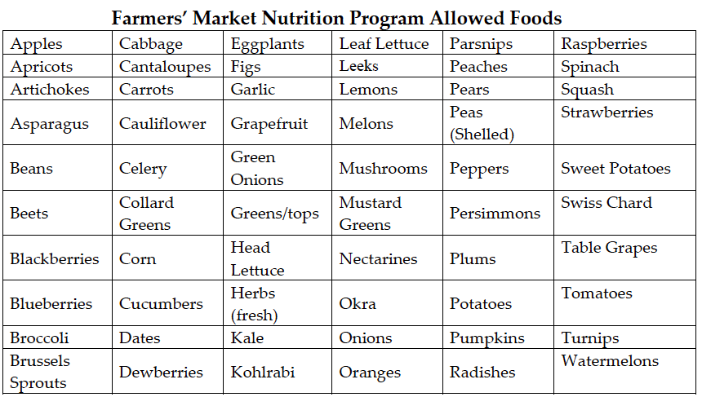

WIC Vouchers may NOT be used to purchase:
Disallowed foods and other non-food items should be physically separated from the eligible foods.
- Dried fruits, vegetables, herbs;
- Eggs, Dairy;
- Honey;
- Baked Goods, Preserved Foods, Prepared Foods;
- Nuts;
- Sauces;
- Meats;
- Flowers, Seeds, Potted Plants;
- Non-food items.
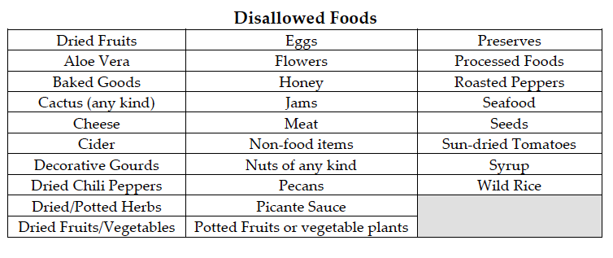
- SNAP

VENDORS ELIGIBLE TO ACCEPT SNAP: DCM Agricultural Producers that meet Criterion B:
More than 50 percent of the total gross retail sales (e.g., food, non-food, services, etc.) at the booth*[store] must be from the sale of eligible staple foods:
Staple foods are the basic foods that make up a significant portion of a person’s diet and are usually prepared at home and eaten as a meal. Staple foods do not include accessory foods, or prepared or heated foods.
Commercially processed foods and prepared mixtures with multiple ingredients are usually assigned to the staple food category of their main ingredient on their “Nutrition Facts” label per current regulations and policy.
Vendors that accept SNAP tokens, must earn more than 50% of their gross retail sales from staple food sales (see lists below).
Process for DCM Staff:
- SNAP clients use their LoneStar EBT (Electronic Benefit Transfer) card at the Denton Community Market booth near the Farmer’s District entrance (near banner) to obtain DCM $1 wooden tokens (as many as needed for purchases) that can be used for qualified items*.
- Market staff runs EBT card, like a debit/credit card, but does NOT charge any transaction fees.
- Once the EBT transaction is approved, DCM Staff provides the number of tokens purchased.
Process for Vendors:
- Accept $1 SNAP tokens as cash for exchanges - no change may be given for SNAP tokens
- At the end of the Market day, redeem all tokens with DCM staff and receive a check for the amount.
*Sales Tax is not charged on SNAP eligible items.
SNAP Tokens may be used to purchase:
- From Vendors that meet Criterion B
- Fruits and vegetables;
- Breads and cereals;
- Meat, fish, and poultry; and
- Dairy products.
- Seeds and plants intended to grow food (herbs, vegetables, fruits, nuts).
What follows is an illustrative, but not exhaustive, list of staple food items NOT considered accessory food items;
Other Items Eligible for SNAP
Examples of (Value Added) Staple Foods:
• Commercially processed foods and prepared mixtures with multiple ingredients with a staple food main ingredient
• Pre-cut, to-go packages or cups of fresh apple, carrot, grapefruit, celery, or other fruits or vegetables
• Single-serving yogurt cups containing or not containing fruit, with a staple food main ingredient
• Milk, flavored milk (e.g., chocolate milk), and plant-based milk alternatives (e.g., soy milk), with a staple food main ingredient
• Yogurt and flavored yogurt (e.g., strawberry yogurt) with a staple food main ingredient
• Dehydrated, smoked, fermented, cured, or dried meats such as jerky or salami with a staple food main ingredient (e.g., beef or chicken)
• Peanut butter, strawberry jam, and other plant-based spreads with a staple food main ingredient
• Fresh vegetables often used as herbs including, but not limited to, fresh basil, fresh thyme, and fresh mint
• 100% fruit and/or vegetable juice
• Salsa, hummus, guacamole, and other plant-based dips with a staple food main ingredient
• Pickled fruits, vegetables, eggs, or meats with a staple food main ingredient
• Single-serving packets of dried fruit including, but not limited to, raisins, prunes, dried apples, and dried papaya spears, as well as dried vegetables
• To-go packages of nuts or seeds

SNAP Tokens may NOT be used to purchase:
- From Vendors that DO NOT meet Criterion B
- Accessory Food Items: snacks, desserts, and foods that complement or supplement meals (includes honey, olive oil, etc.). (see list below)
- Foods that are hot at the point of sale (prepared foods);
- Food to be eaten on site;
- Pet Foods;
- Nonfood items
What follows is a list of accessory food items; any product not listed below or in future Agency guidance will be considered a staple food, as explained above, provided that its main ingredient is considered a variety in the staple food category.
Accessory Food Items are NOT eligible for SNAP
(The list in the Accessory Food Items document is not comprehensive, but is meant as a contextual guide. Foods such as brownies and sweet dessert baked items that are usually consumed as a snack or dessert are considered accessory food items, even if, in their preparation, the main ingredient is a staple food.)
Snack and Dessert Food Items:
• Potato, corn, wheat, tortilla, pita, and vegetable chips, crisps, sticks, and straws; onion ring snacks; corn nuts; snack mixes; crackers; pork rinds; pretzels; pre-popped or unpopped popcorn; and cheese puffs or curls
• Doughnuts, cupcakes, cookies, snack cakes, muffins, pastries, sweet rolls, pies, cakes, pudding, churros, scones, gelatin desserts, and any packaged mixes intended to create any of the aforementioned products. *This includes brownies, sweet/quick breads, and dessert type baked items that are typically consumed as a dessert or snack.
• Mints, chocolate, marshmallow, gum, toffee, brittle, fudge, marzipan, nougat, candy bars, and candy of all kinds
• Ice cream, ice milk, frozen yogurt, custard, whipped cream, sherbet, sorbet, gelato, granita, Italian ices, frozen carbonated beverages, snow cones, and ice pops
• Any food product with a main ingredient that appears on this list or in Agency guidance as an accessory food item
Food Items That Complement or Supplement Meals:
• Powdered, dried, or extracted spices or seasonings
• Baking soda and baking powder
• Sugar, honey, maple syrup, aspartame, molasses, high fructose corn syrup, and any other natural or artificial sweeteners
• Soda pop, sports or energy drinks, iced tea, fruit punch, mixers for alcoholic beverages, water, and all other carbonated or uncarbonated beverages (except milk, plant-based milk alternatives, and 100% fruit or vegetable juice)
• Monosodium glutamate, sodium nitrate, olestra, and any other food additives or any food product that is edible but non-caloric and non-digestible
• Vegetable oil, olive oil, shortening, lard, safflower oil, and any other solid or liquid oils or fats (except butter)
• Ketchup, mayonnaise, salad dressing, hot sauce, mustard, vinegar, relish, horseradish, chutney, duck sauce, marmite, and all other condiments
• Vanilla extract or other flavor extracts and cooking wine
• Gravy and bouillon
• Any food product with a main ingredient that appears on this list or in Agency guidance as an accessory food item

